**Geometry**

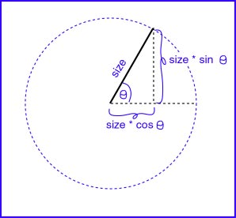

Consider the method that draws the star:

drawStar(Graphics g, int x, int y, int size)

Each line (of the six) starts at the center, and ends at a point on the circle of radius size. The X distance from the center of a point on a circle is size*cos(theta). The Y distance from the center of a point on a circle is size*sin(theta).

All you need to do is find the six values for theta and the six endpoints are yours.

Recall there are two Pi radians in a circle.

The six lines will be at angles 0, 1*(2pi)/6, 2*(2pi)/6, 3*(2pi)/6, ...

The Java trigonometric functions are static methods of the Math class. They use radians for their arguments.

The circle is divided into six pieces. The constant pi is available in Java as Math.PI. There are two pi radians per circle. One sixth of a circle is (2 * Math.PI / 6).